Batch: B1 Roll No.: 16010120074

Experiment / assignment / tutorial No.06

Grade: AA / AB / BB / BC / CC / CD /DD

Signature of the Staff In-charge with date

TITLE :Case Study (for Class Diagram)

AIM: Draw class Diagram for the chosen Case Study . Clearly show
  - Attributes
  - Multiplicities between classes
  - Aggregations/compositions/Association between classes
  - Generalization between classes in the class diagram.
And show the implementation of aggregation, association, composition and generalization between the classes.
__________________________________________________________________
Expected OUTCOME of Experiment:
CO1: Understand the features of object oriented programming compared with procedural approach with C++ and Java.
CO2: Explore arrays, vectors, classes and objects in C++ and Java.
CO3: Implement scenarios using object oriented concepts (Drawing class diagram, relationship between classes, sequence diagram)
CO4: Explore the interface, exceptions, multithreading, packages
_____________________________________________________________________
Books/ Journals/ Websites referred:

1.Ralph Bravaco , Shai Simoson , “Java Programing From the Group Up” Tata McGraw-Hill.

2.Grady Booch, Object Oriented Analysis and Design .
____________________________________________________________________
Pre Lab/ Prior Concepts:

Define Class, Methods, Object.
Understanding of Aggregation, Association, Composition and Generalization between classes

System Requirements:

- User is registered.
- Booking is made or edited or deleted.
- If booking is being made then a train is selected for booking.
- After this payment takes place.
- Then the ticket details are displayed.
- Admin can edit the train details. User does not have any sort of access to editing the train details.

List Of Classes:

Class Userr
Class Railways
Class Booking
Class Dataa
Class Admin
Identify Attributes for each class:

Class Dataa :
Username: String
Date: Int
Month: Int
Year: Int
Gender: String
Password: String
Train_name: String
Seats: Int
Source_station: String
Destination_station: String
Departure_time: Int
Arrival_time: Int
Train_cost: Double
D: Int
M: Int
Y: Int
G: String
Tn: String
Ss: String
Ds: String
Dt: Int
At: Int
Tc: Double

Identify List of Methods in each classes:

Class Userr:
New_User()
Existing_User()
Delete_User()
Class Booking:
Add_Booking()
Delete_Booking()
Add_Booking_Admin()
Class Admin:
Add_Train()
Delete_Train()
Class Dataa:
Display()

Class Diagram:

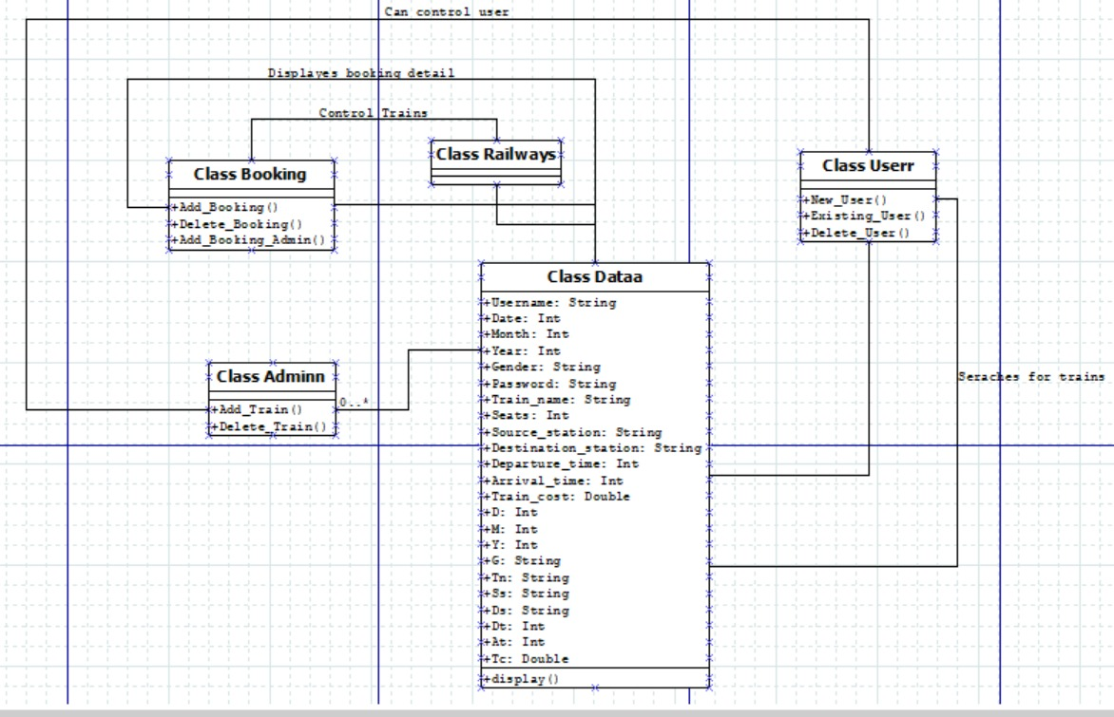

Implementation details:
import java.lang.Math;
import java.util.Scanner;
public class Railways {
public static void main(String[] args) {
Scanner sc = new Scanner(System.in);
int k = 0, z = 0;
Adminn ad = new Adminn();
Userr us = new Userr();
Booking bk = new Booking();
boolean outFlag = true;
while (outFlag) {
System.out.println(
"Hello! Welcome to Railyway Management System. If you are a user press '1' else if you are a admin press '2'.If you want to exit press '3'");
k = sc.nextInt();
switch (k) {
case 1:
boolean in2Flag = true;
while (in2Flag) {
System.out.println(
"If you are new user press '1'. If a existing user press '2'.If you want to exit press '3'.");
int a = sc.nextInt();
switch (a) {
case 1:
us.New_User();
System.out.println("To continue towards booking a ticket press '1' else to log out press '2'");
int choice = sc.nextInt();
switch (choice) {
case 1:
int ite = us.i;
ite--;
System.out.println("Username: " + us.user[ite].Username + "\nDate of Birth: "
+ us.user[ite].Date + " " + us.user[ite].Month + " " + us.user[ite].Year
+ "Gender : " + us.user[ite].Gender);
int train_ite = 0;
for (train_ite = 0; train_ite < ad.t; train_ite++) {
if (ad.Train[train_ite] != null) {
System.out.println("For train" + train_ite);
ad.Train[train_ite].display();
} else {
System.out.println("\nThere is no train to display at this position\n");
}
}
System.out.println("Enter the train name that you want to book");
String book_train_name = sc.next();
int iterator = 0;
for (iterator = 0; iterator < 100; iterator++) {
if (book_train_name.equals(ad.Train[iterator].Train_name)) {
System.out.println("You have chosen your train as " + book_train_name
+ "Please proceed with the payment");
System.out.println("The amount to be paid is : " + ad.Train[iterator].Train_cost);
} else {
System.out.println("Please enter the correct Train name");
}
}
System.out.println("After the payment of amount press enter the OTP received");
double Random = Math.random();
System.out.println(Random);
int OTP = sc.nextInt();
if (OTP == Random) {
System.out.println("Your payment is successful.Following are your final details");
ad.Train[iterator].Seats--;
System.out.println("Username: " + us.user[ite].Username + "\nDate of Birth: "
+ us.user[ite].Date + " " + us.user[ite].Month + " " + us.user[ite].Year
+ "Gender : " + us.user[ite].Gender + "Train name booked" + book_train_name
+ "Source Station of the Train" + ad.Train[iterator].Source_station
+ "Destination Station of the Train" + ad.Train[iterator].Destination_station
+ "Time of departure of the train" + ad.Train[iterator].Departure_time
+ "\nTime of arrival of the train\n" + ad.Train[iterator].Arrival_time
+ "The total cost is:" + ad.Train[iterator].Train_cost);
bk.booking[ite] = new Dataa(us.user[ite].Username, us.user[ite].Date,
us.user[ite].Month, us.user[ite].Year, us.user[ite].Gender, book_train_name,
ad.Train[iterator].Source_station, ad.Train[iterator].Destination_station,
ad.Train[iterator].Departure_time, ad.Train[iterator].Arrival_time,
ad.Train[iterator].Train_cost);
}
break;
case 2:
// System.exit(0);
break;
case 3:
break;
}
break;
case 2:
us.Existing_User();
bk.Add_Booking();
break;
case 3:
// System.exit(0);
// System.out.println("out");
in2Flag = false;
break;
}
}
break;
case 2:
System.out.println("Enter the password for admin");
int pass = sc.nextInt();
if (pass == 1234) {
boolean flag = true;
while (flag) {
System.out.println(
"What action do you want to perform? \n 1. Add a Train 2. Delete a Train 3. Add User 4. Delete a user 5. Add a Booking 6. Delete a Booking 7.Exit");
int m = sc.nextInt();
switch (m) {
case 1:
ad.Add_Train();
break;
case 2:
ad.Delete_Train();
break;
case 3:
us.New_User();
break;
case 4:
us.Delete_User();
break;
case 5:
bk.Add_Booking_Admin();
break;
case 6:
bk.Delete_Booking();
break;
case 7:
flag = false;
// System.exit(0);
break;
}
}
} else {
System.out.println("Please enter the correct password");
}
break;
case 3:
outFlag = false;
break;
}
}
}
}
class Userr {
Scanner scanner = new Scanner(System.in);
int i = 0;
int s = 10;
int j = 0;
Dataa[] user = new Dataa[s];
void New_User() {
System.out.println("Enter a new username");
String b = scanner.next();
System.out.println("Enter the Date of your birth in the following format : dd ");
int c = scanner.nextInt();
System.out.println("Enter the month of your birth in the following format: mm");
int d = scanner.nextInt();
System.out.println("Enter the year of your birth in the following format: yy");
int e = scanner.nextInt();
System.out.println("Enter your Gender");
String gender = scanner.next();
System.out.println("Enter a secure password for your account");
String f = scanner.next();
user[i] = new Dataa(b, c, d, e, gender, f);
i++;
System.out.println("Thankyou.Your account has been successfully created");
}
void Existing_User() {
int count = 0;
System.out.println("Please enter your username");
String g = scanner.nextLine();
System.out.println("Please enter the password");
String h = scanner.nextLine();
for (j = 0; j < s; j++) {
if (h.equals(user[j].Password)) {
System.out.println("You have successfully logged into your account");
count = 1;
}
}
if (count != 1) {
System.out.println("Invalid credentials entered.Please log in again");
// System.exit(0);
}
}
void Delete_User() {
int count = 0;
System.out.println("\nPlease enter the name of the person whose account you want to delete\n");
String name = scanner.next();
for (int r = 0; r < s; r++) {
if (name.equals(user[r].Username)) {
for (int v = r; v < (s - 1); v++) {
user[v] = user[v + 1];
}
count = 1;
System.out.println("\nThe user has been successfully deleted\n");
}
}
if (count != 1)
System.out.println("\nThe user is not found\n");
}
}
class Adminn {
int t = 100, z = 0;
Scanner scc = new Scanner(System.in);
Dataa[] Train = new Dataa[t];
void Add_Train() {
System.out.println("Enter the train name");
String l = scc.next();
System.out.println("Enter the number of seats in the train");
int seats = scc.nextInt();
System.out.println("Enter the train Source Station");
String n = scc.next();
System.out.println("Enter the train Destination Station");
String o = scc.next();
System.out.println("Enter the time of departure of the train");
int p = scc.nextInt();
System.out.println("Enter the time of arrival of the train");
int q = scc.nextInt();
System.out.println("Enter the cost of the ticket");
double cost = scc.nextDouble();
Train[z] = new Dataa(l, seats, n, o, p, q, cost);
z++;
System.out.println("The train has been successfully added");
return;
}
void Delete_Train() {
int countt = 0;
System.out.println("\nPlease enter the name of the train you want to delete\n");
String train_name = scc.next();
for (int w = 0; w < t; w++) {
if (Train[w] != null) {
if (train_name.equals(Train[w].Train_name)) {
for (int x = w; x < (t - 1); x++) {
Train[x] = Train[x + 1];
}
countt = 1;
System.out.println("\nThe train has been successfully deleted\n");
}
}
}
if (countt != 1)
System.out.println("\nThe train is not found\n");
}
}
class Dataa {
Scanner scanner = new Scanner(System.in);
public String Username;
public int Date;
public int Month;
public int Year;
public String Gender;
public String Password;
Dataa(String Username, int Date, int Month, int Year, String Password, String Gender) {
this.Username = Username;
this.Date = Date;
this.Month = Month;
this.Year = Year;
this.Gender = Gender;
this.Password = Password;
}
public String Train_name;
public int Seats;
public String Source_station;
public String Destination_station;
public int Departure_time;
public int Arrival_time;
public double Train_cost;
Dataa(String Train_name, int Seats, String Source_station, String Destination_station, int Departure_time,
int Arrival_time, double Train_cost) {
this.Train_name = Train_name;
this.Seats = Seats;
this.Source_station = Source_station;
this.Destination_station = Destination_station;
this.Departure_time = Departure_time;
this.Arrival_time = Arrival_time;
this.Train_cost = Train_cost;
}
public void display() {
System.out.println("\nThe Train name is : " + Train_name + "\n" + "The seats available in the train are:"
+ Seats + "The Source station is : " + Source_station + "\n" + "The Destination station is : "
+ Destination_station + "\n" + "The Departure time is : " + Departure_time + "\n"
+ "The Arrival time is : " + Arrival_time);
}
public String Un;
public int D;
public int M;
public int Y;
public String G;
public String Tn;
public String Ss;
public String Ds;
public int Dt;
public int At;
public double Tc;
Dataa(String Un, int D, int M, int Y, String G, String Tn, String Ss, String Ds, int Dt, int At, double Tc) {
this.Un = Un;
this.D = D;
this.M = M;
this.Y = Y;
this.G = G;
this.Tn = Tn;
this.Ss = Ss;
this.Ds = Ds;
this.Dt = Dt;
this.At = At;
this.Tc = Tc;
}
}
class Booking {
Railways r = new Railways();
Userr uss = new Userr();
Scanner sc = new Scanner(System.in);
Adminn ad = new Adminn();
int x = 10;
int j = uss.j;
int a = 0;
int i = 0;
Dataa[] booking = new Dataa[x];
void Add_Booking() {
System.out.println("Username: " + uss.user[j].Username + "\nDate of Birth: " + uss.user[j].Date + " "
+ uss.user[j].Month + " " + uss.user[j].Year + "Gender : " + uss.user[j].Gender);
for (int train_itee = 0; train_itee < ad.t; train_itee++) {
if (ad.Train[train_itee] != null) {
System.out.println("For train" + train_itee);
ad.Train[train_itee].display();
} else {
System.out.println("\nThere is no train to display at this position\n");
}
}
System.out.println("Enter the train name that you want to book");
String book_train_name = sc.next();
int iteratorr = 0;
for (iteratorr = 0; iteratorr < 100; iteratorr++) {
if (book_train_name.equals(ad.Train[iteratorr].Train_name)) {
System.out.println(
"You have chosen your train as " + book_train_name + "Please proceed with the payment");
System.out.println("The amount to be paid is : " + ad.Train[iteratorr].Train_cost);
} else {
System.out.println("Please enter the correct Train name");
}
}
System.out.println("After the payment of amount press enter the OTP received");
double Randomm = Math.random();
System.out.println(Randomm);
int OTP = sc.nextInt();
if (OTP == Randomm) {
System.out.println("Your payment is successful.Following are your final details");
ad.Train[iteratorr].Seats--;
System.out.println("Username: " + uss.user[j].Username + "\nDate of Birth: " + uss.user[j].Date + " "
+ uss.user[j].Month + " " + uss.user[j].Year + "Gender : " + uss.user[j].Gender
+ "Train name booked" + book_train_name + "Source Station of the Train"
+ ad.Train[iteratorr].Source_station + "Destination Station of the Train"
+ ad.Train[iteratorr].Destination_station + "Time of departure of the train"
+ ad.Train[iteratorr].Departure_time + "\nTime of arrival of the train\n"
+ ad.Train[iteratorr].Arrival_time + "The total cost is:" + ad.Train[iteratorr].Train_cost);
booking[j] = new Dataa(uss.user[j].Username, uss.user[j].Date, uss.user[j].Month, uss.user[j].Year,
uss.user[j].Gender, book_train_name, ad.Train[iteratorr].Source_station,
ad.Train[iteratorr].Destination_station, ad.Train[iteratorr].Departure_time,
ad.Train[iteratorr].Arrival_time, ad.Train[iteratorr].Train_cost);
}
}
void Delete_Booking() {
int count = 0;
int countt = 0;
System.out.println("Enter the name of the user whose booking you want to delete");
String name = sc.next();
for (i = 0; i < x; i++) {
if (name.equals(booking[i].Un)) {
System.out.println("The account has been found.To confirm the deletion of booking press '1'");
System.out.println("Username: " + booking[i].Un + "\nDate of Birth: " + booking[i].D + " "
+ booking[i].M + " " + booking[i].Y + "Gender : " + booking[i].G + "Train name booked"
+ booking[i].Tn + "Source Station of the Train" + booking[i].Ss
+ "Destination Station of the Train" + booking[i].Ds + "Time of departure of the train"
+ booking[i].Dt + "\nTime of arrival of the train\n" + booking[i].At + "The total cost is:"
+ booking[i].Tc);
count = 1;
}
}
if (count == 0) {
System.out.println("There is no account with that name");
// System.exit(0);
}
for (int z = i; z < (x - 1); z++) {
booking[i] = booking[i + 1];
}
x--;
countt = 1;
for (int j = 0; j < ad.t; j++) {
if (booking[i].Tn.equals(ad.Train[j].Train_name)) {
ad.Train[j].Seats++;
}
}
System.out.println("\nThe booking has been successfully deleted\n");
if (countt != 1)
System.out.println("\nThe booking is not found\n");
}
void Add_Booking_Admin() {
int count = 0;
System.out.println("Enter the name of the user for whom you would like to add a booking");
String name = sc.next();
for (a = 0; a < uss.s; a++) {
if (name.equals(uss.user[a].Username)) {
System.out.println("User found.");
count = 1;
}
}
if (count == 0) {
System.out.println("No user found enter correct name");
}
System.out.println("Username: " + uss.user[a].Username + "\nDate of Birth: " + uss.user[a].Date + " "
+ uss.user[a].Month + " " + uss.user[j].Year + "Gender : " + uss.user[a].Gender);
for (int train_itee = 0; train_itee < ad.t; train_itee++) {
if (ad.Train[train_itee] != null) {
System.out.println("For train" + train_itee);
ad.Train[train_itee].display();
} else {
System.out.println("\nThere is no train to display at this position\n");
}
}
System.out.println("Enter the train name that you want to book");
String book_train_name = sc.next();
int iteratorr = 0;
for (iteratorr = 0; iteratorr < 100; iteratorr++) {
if (book_train_name.equals(ad.Train[iteratorr].Train_name)) {
System.out.println(
"You have chosen your train as " + book_train_name + "Please proceed with the payment");
System.out.println("The amount to be paid is : " + ad.Train[iteratorr].Train_cost);
} else {
System.out.println("Please enter the correct Train name");
}
}
System.out.println("After the payment of amount press enter the OTP received");
double Randomm = Math.random();
System.out.println(" " + Randomm);
int OTP = sc.nextInt();
if (OTP == Randomm) {
System.out.println("Your payment is successful.Following are your final details");
ad.Train[iteratorr].Seats--;
System.out.println("Username: " + uss.user[a].Username + "\nDate of Birth: " + uss.user[a].Date + " "
+ uss.user[a].Month + " " + uss.user[a].Year + "Gender : " + uss.user[a].Gender
+ "Train name booked" + book_train_name + "Source Station of the Train"
+ ad.Train[iteratorr].Source_station + "Destination Station of the Train"
+ ad.Train[iteratorr].Destination_station + "Time of departure of the train"
+ ad.Train[iteratorr].Departure_time + "\nTime of arrival of the train\n"
+ ad.Train[iteratorr].Arrival_time + "The total cost is:" + ad.Train[iteratorr].Train_cost);
booking[j] = new Dataa(uss.user[a].Username, uss.user[a].Date, uss.user[a].Month, uss.user[a].Year,
uss.user[a].Gender, book_train_name, ad.Train[iteratorr].Source_station,
ad.Train[iteratorr].Destination_station, ad.Train[iteratorr].Departure_time,
ad.Train[iteratorr].Arrival_time, ad.Train[iteratorr].Train_cost);
}
}
}

Output:
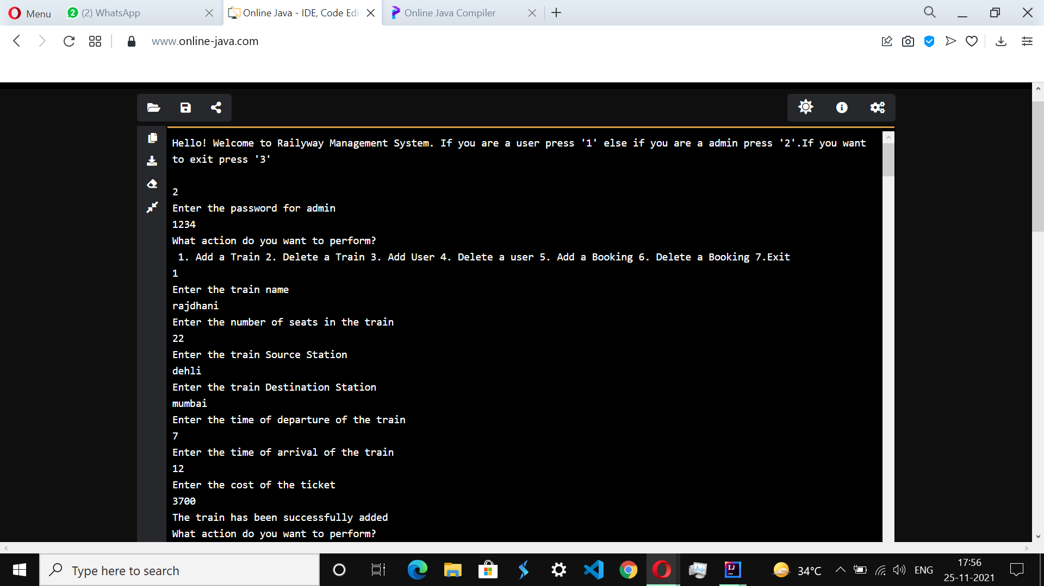
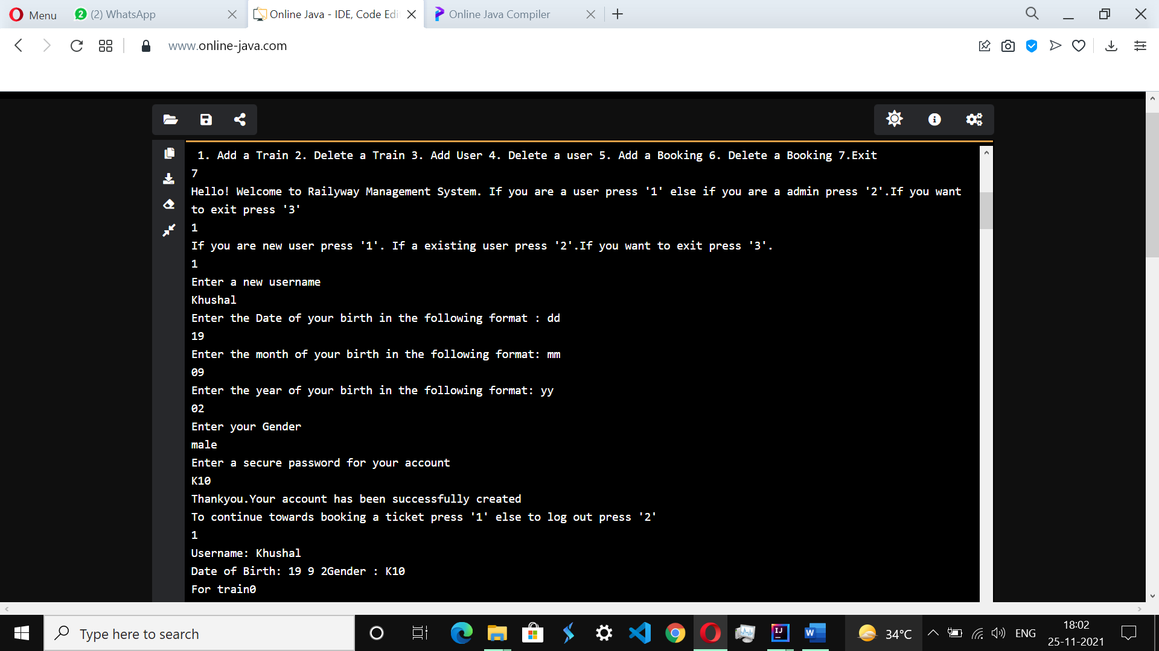
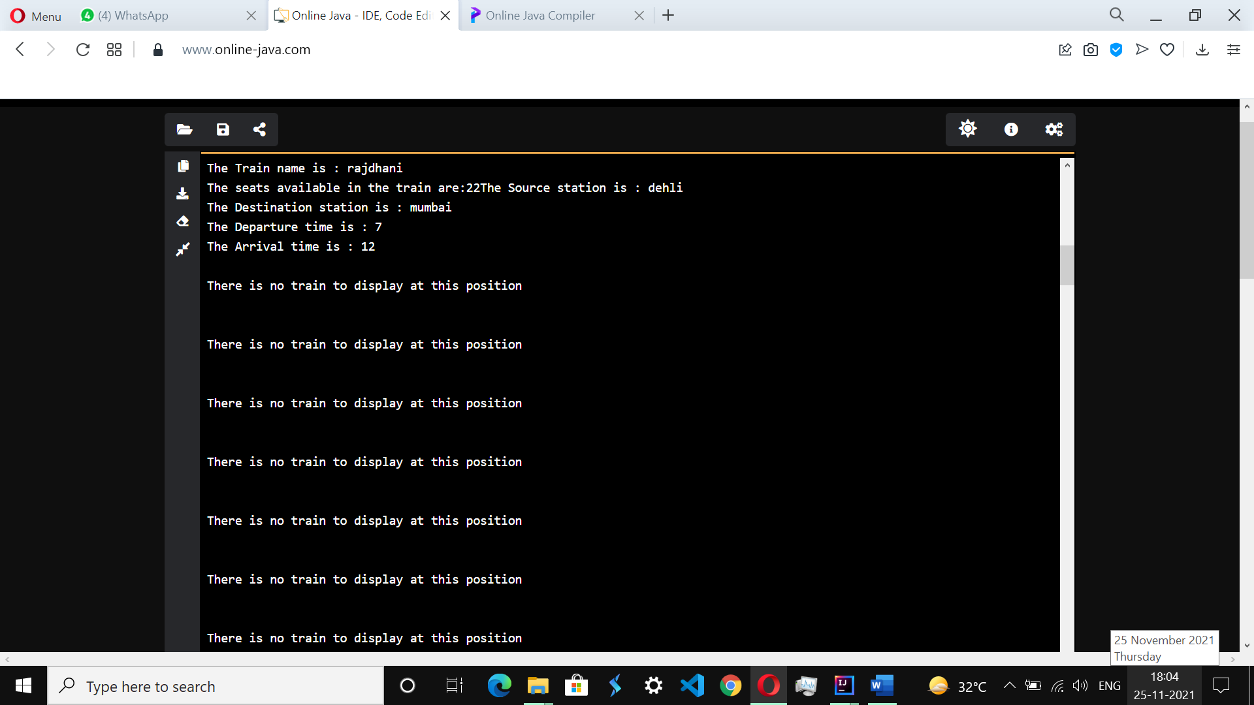
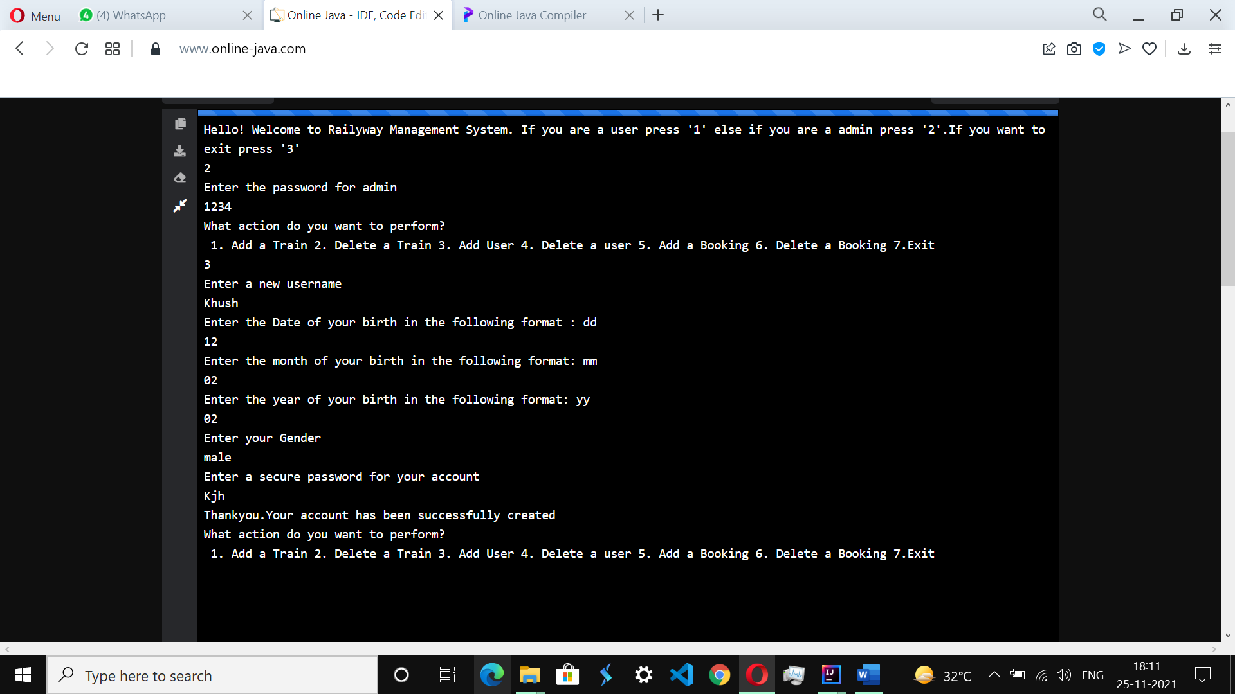

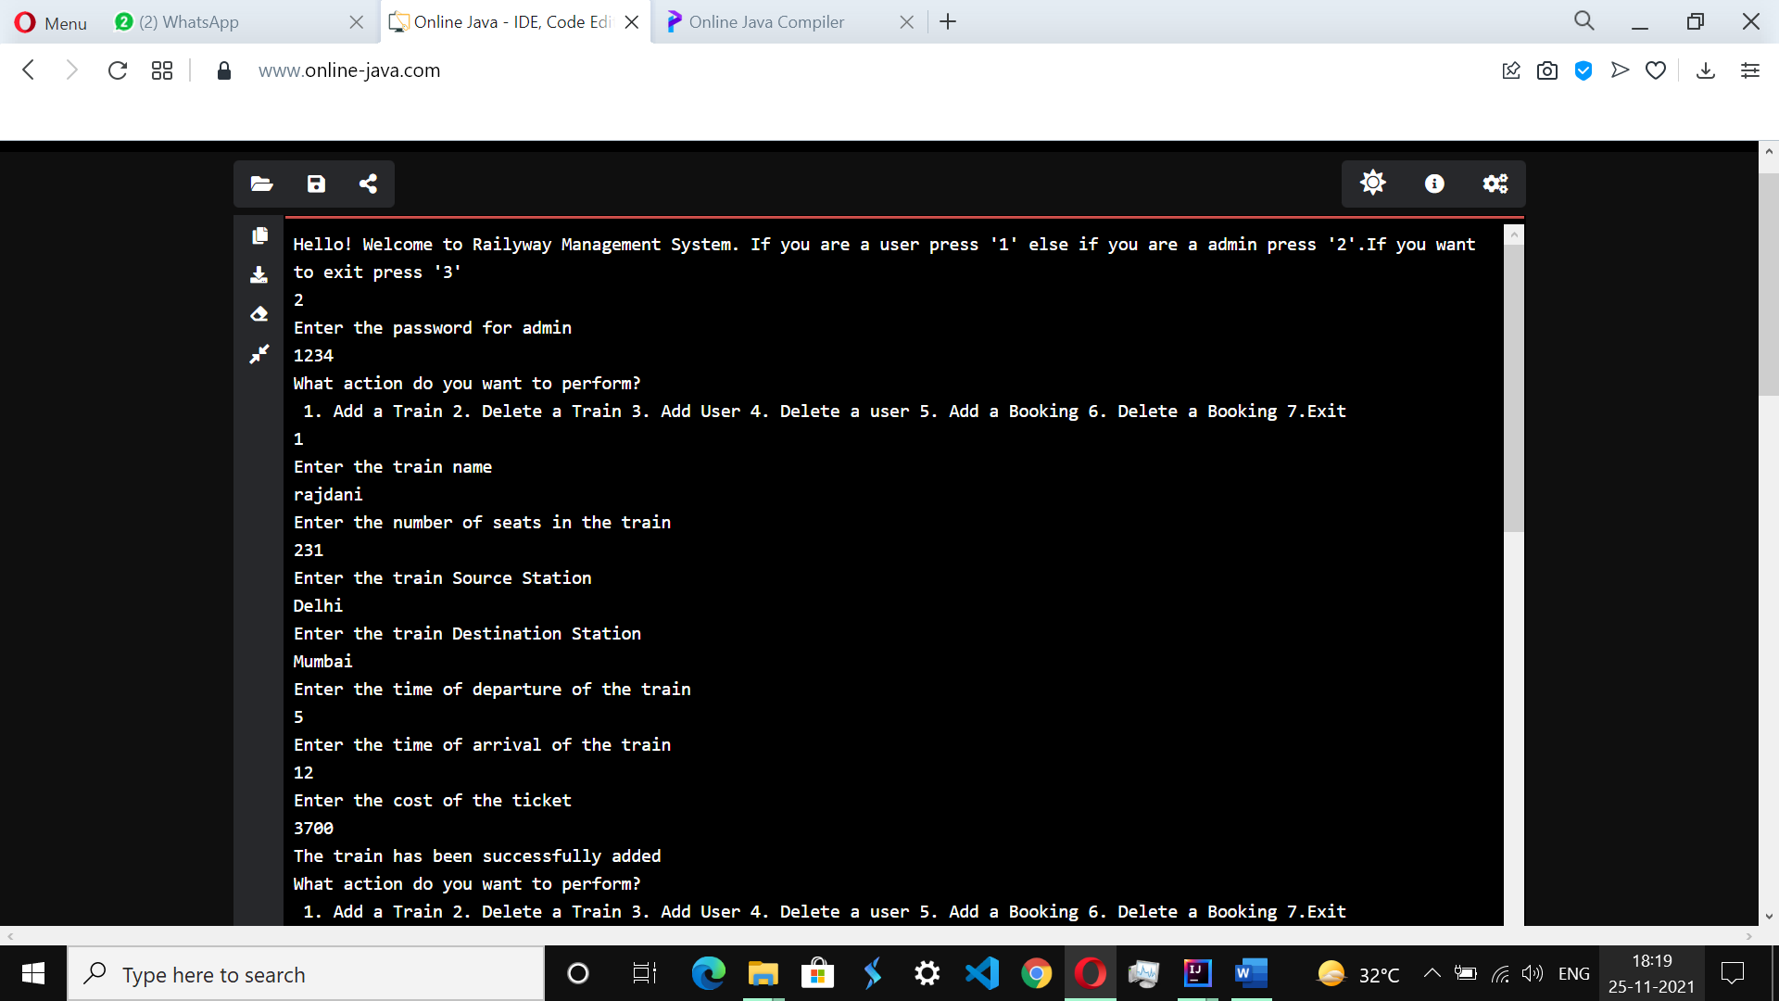
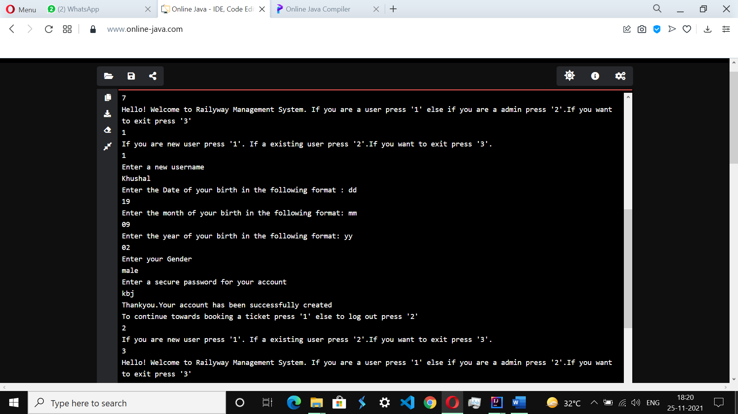
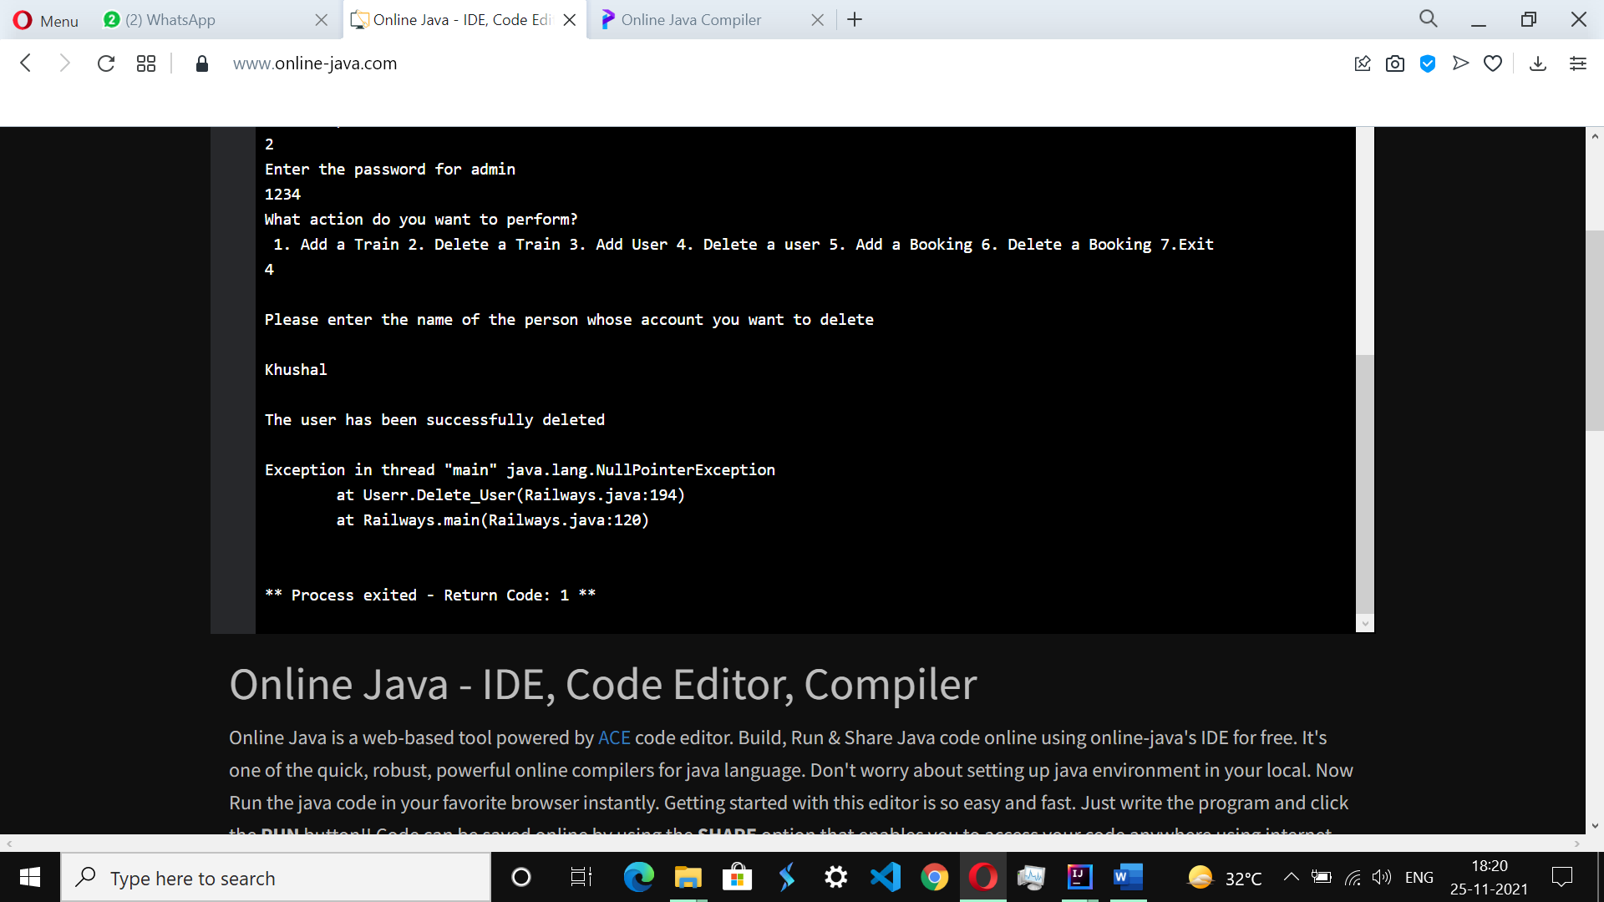
Conclusion:
The concept, applications and aspects of class diagram were understood and a program was successfully implemented.

Post Lab Descriptive Questions
1. Consider the following class:
public class TypeOfVariable{
public static int a;
int b,c;
public void printValue(){
int x = 10;
}
public static void main(String args[]){
TypeOfVariable object=new TypeOfVariable();
object.printValue();
}
}
a). What are the class/static variables?

b). What are the instance variables?

c.)What are local variables?

2.What is the output from the following code:
public class Test
{
static int x = 11;
private int y = 33;
public void method1(int x)
{
Test t = new Test();
this.x = 22;
y = 44;

System.out.println("Test.x: " + Test.x);
System.out.println("t.x: " + t.x);
System.out.println("t.y: " + t.y);
System.out.println("y: " + y);
}

public static void main(String args[])
{
Test t = new Test();
t.method1(5);
}
}

